LAB 4 REPORT – RF ELECTRONICS

FERGAL LONERGAN 13456938

### DESIGN 3, 0.5dB Ripple, 2GHz- Cut-off Frequency, 20dB @ 3.2GHz – Minimum insertion loss

# Question 1

## What are the advantages and disadvantages of using a 0.5 dB ripple Chebyshev filter instead of a maximally flat Butterworth filter?

The advantages of using a 0.5dB ripple Chebyshev filter over a maximally flat Butterworth filter is that the roll off of the stop band is a lot steeper, i.e. it attenuates frequencies close to the cut-off a lot better, however a maximally flat Butterworth filters are used where a maximally pass band flatness is required, i.e, in a Butterworth filter regardless what the frequency of the signal is it will have the same amplification of 1 once it is in the pass band.

# Question 2

## Lumped Element Filter - plot the forward transmission (S21) and reflection (S11) coefficients (in dB) to see whether the design specifications are met.

We used my student number so our design was based on Design 3, a 0.5dB Ripple Chebyshev filter with a 2GHz Cut-off Frequency and a minimum insertion loss of 20dB @ 3.2GHz.

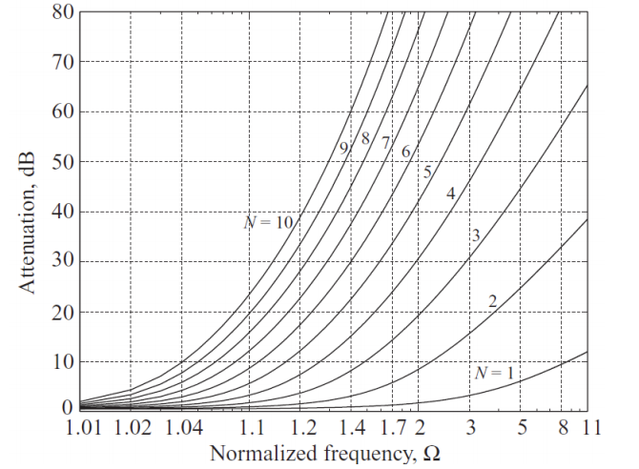

Looking at the graph and getting our normalised frequency of $\frac{3.2GHz}{2GHz}=1.6$ we see that seeing as our filter must be of an odd order to satisfy matching with our source and load impedances we must have a 5th order filter.

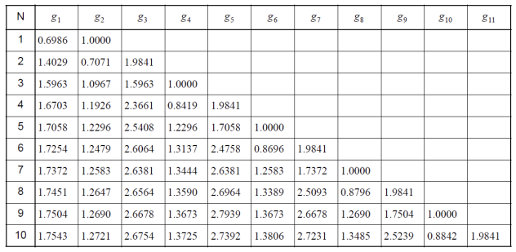

We see that the 5th order Chebyshev filter gives us the following normalised elements:

|  |  |
| --- | --- |
| Element | Normalised Value |
| $$R_{G}$$ | 1 |
| $$C_{1}$$ | 1.7058 |
| $$L_{2}$$ | 1.2296 |
| $$C_{3}$$ | 2.5408 |
| $$L_{4}$$ | 1.2296 |
| $$C_{5}$$ | 1.7058 |
| $$R_{L}$$ | 1 |

Our de-normalised values were then:

|  |  |
| --- | --- |
| Element | De-normalised Value |
| $$R_{G}$$ | 50 |
| $$C_{1}$$ | 2.714pF |
| $$L_{2}$$ | 4.892nH |
| $$C_{3}$$ | 4.044pF |
| $$L_{4}$$ | 4.892nH |
| $$C_{5}$$ | 2.714pF |
| $$R_{L}$$ | 50 |

So we designed the following lumped element filter:

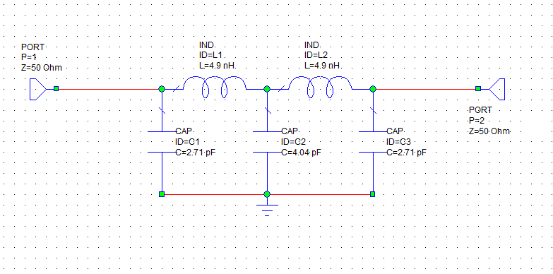

We then plot the forward transmission co-efficient, S(2,1), and the reflection co-efficient, S(1,1) in dB to check if our specifications were met.

As we see from the graph below at 2GHz, our cut-off frequency, the forward transmission coefficient is reading almost exactly 0dB so none of our signal is being attenuated, as we want, but our filter definitely begins to attenuate frequencies larger than this value which is as we designed.

Our insertion loss at 3.2GHz is also approximately 30dB which is 150% that of our minimum insertion loss value given to us in our specifications, 20dB. We also note that at around 2.5GHz our reflection coefficient reaches approximately 0dB, or 1, so it is reflecting all the signals transmitting at a higher frequency than 2.5GHz.

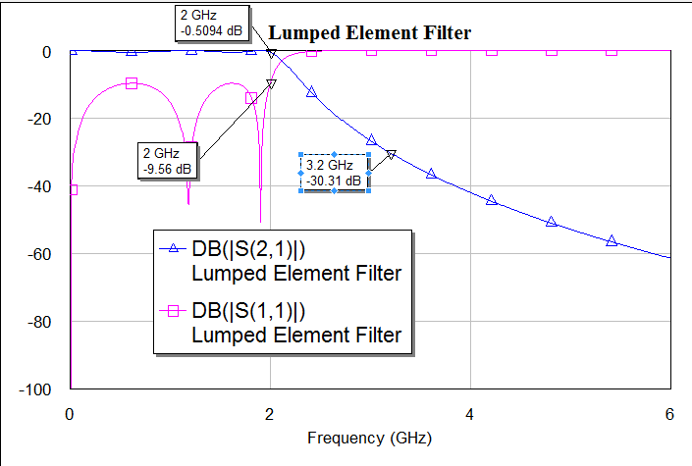

# Question 3

## Microstrip Line- the “Snap Together” button on the toolbar. You should now see your entire filter layout. Is it as you expected?

We then converted our Lumped Element filter design into a microstrip line filter using the following parameter values:

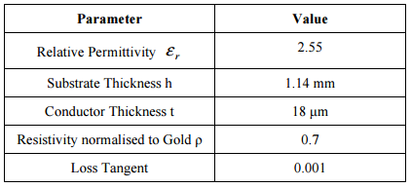

We were given an upper limit of 110 $Ω$ so we chose this initially as our design parameter for our inductor microstrip line designs, however, we noticed that after we used the TX line program in microwave office that the widths it was returning for our microstrip line filter were too small to be fabricated, as a result we chose 75 $Ω$ which was well within our lower bound of 20 $Ω.$ We then chose 20 $Ω$ for our capacitors.

We first had to find the electrical length for our lines using the normalized values for our Chebyshev filter:

|  |  |
| --- | --- |
| Element | Normalised Value |
| $$R_{G}$$ | 1 |
| $$C_{1}$$ | 1.7058 |
| $$L_{2}$$ | 1.2296 |
| $$C_{3}$$ | 2.5408 |
| $$L_{4}$$ | 1.2296 |
| $$C_{5}$$ | 1.7058 |
| $$R_{L}$$ | 1 |

We not values repeat so they will have the same electrical length:

$$βd=\frac{LR_{0}}{Z_{h}}, βd=\frac{CZ_{l}}{R_{0}}$$

$$R_{0}=50, Z_{h}=75, Z_{l}=20$$

$$C_{1}\& C_{5}: βd=\frac{1.7508\left(20\right)}{50}*\frac{180}{π}= 34.44$$

$$L_{2}\& L_{4}:βd=\frac{1.2296\left(50\right)}{75}*\frac{180}{π}= 46.96$$

$$C_{3}:βd=\frac{2.5408\left(20\right)}{75}*\frac{180}{π}= 58.23$$

To get our resistances we knew that we wanted a length of 10mm transmission line either end of our circuit so we just fed that into our TX line software instead of our Electrical length.

The following where the elements, transformed into transmission lines, and their corresponding widths and lengths:

|  |  |  |
| --- | --- | --- |
| Element | Width (in mm) | Length (in mm) |
| $$R_{G}$$ | 3.337 | 10 |
| $$C_{1}$$ | 11.36 | 10.685 |
| $$L_{2}$$ | 1.688 | 13.712 |
| $$C_{3}$$ | 11.355 | 15.77 |
| $$L_{4}$$ | 1.688 | 13.712 |
| $$C_{5}$$ | 11.36 | 10.685 |
| $$R_{L}$$ | 3.337 | 10 |

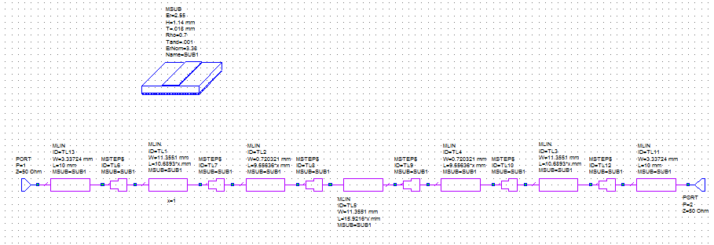

The values for the above filter are for the circuit when we used 110 $Ω$ as our $Z_{h}.$

# Question 4

# Lengths - Record these values. Are they as designed?

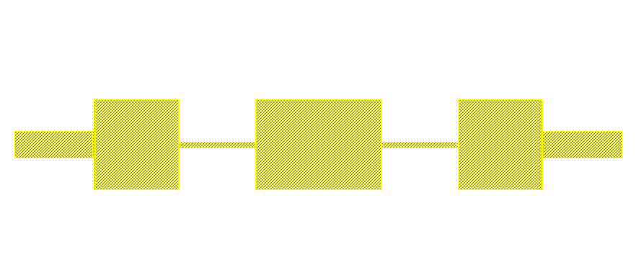

We then generated our microstrip line filter and measured each of the measurements. The above filter was for when we used 110 $Ω$ as our $Z_{h}.$ For our $Z_{h}$ of 75 $Ω$ our inductance strips were slightly wider.

For our filter using a $Z_{h}$ of 75 $Ω$ we measured the following values which were practically the exact same as our designed microstrip circuit.

|  |  |  |  |  |
| --- | --- | --- | --- | --- |
| Element | Width (in mm) | Length (in mm) | Width of microstrip (in mm) | Length of microstrip (in mm) |
| $$R_{G}$$ | 3.337 | 10 | 3.33 | 10 |
| $$C_{1}$$ | 11.36 | 10.685 | 11.35 | 10.685 |
| $$L_{2}$$ | 1.688 | 13.712 | 1.688 | 13.712 |
| $$C_{3}$$ | 11.355 | 15.77 | 11.355 | 15.77 |
| $$L_{4}$$ | 1.688 | 13.712 | 1.688 | 13.712 |
| $$C_{5}$$ | 11.36 | 10.685 | 11.35 | 10.685 |
| $$R_{L}$$ | 3.337 | 10 | 3.33 | 10 |

# Question 5

## Microstrip - Add a graph (including some identification in the title), displaying the S21 scattering parameters (in dB) versus frequency for your Microstrip filter. Add a marker at your required maximum attenuation frequency. Is it as expected? Does it satisfy the specifications? If not, how can it be fixed? Adjust your circuit until it meets the specifications.

We then compared the scattering parameters of our Lumped element and Microstrip filters. We see that from our graph our microstrip filter begins cutting off a bit prematurely at about 1.8GHz but we were happy that it was close enough to our specifications. This means that at 2GHz in our microstrip filter the signal will be attenuated significantly more than our lumped emelent filter would attenuate it and so the microstrip filter can be seen as a more effective filter. We also have 26dB insertion loss at 3.2GHz which meets our specifications of 20dB insertion loss at 3.2GHz. Our microstrip filter also doesn’t attenuate a very short band of frequencies as well as it should at around 5.7 GHz.

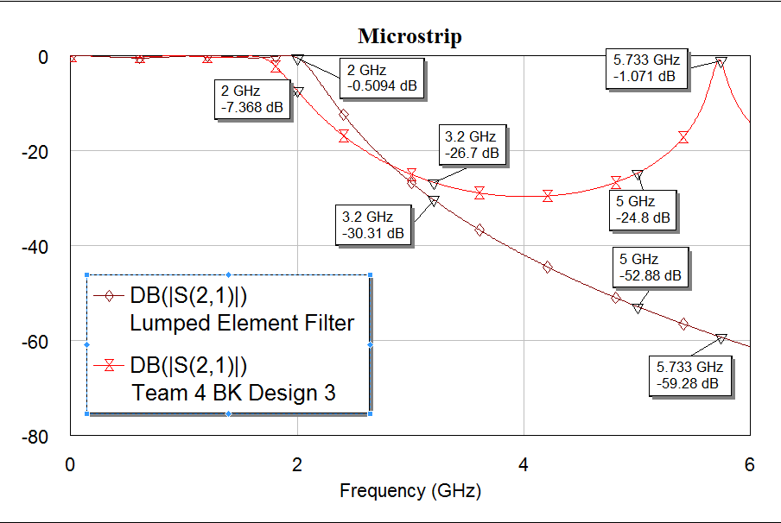

Team 20 FL Microstrip Design

# Question 6

## Comparison - Compare the traces. Are they the same? Now add a graph of phase versus frequency – Phase(S(2,1)) – for both filters and compare the results. Print out a copy of the two graphs and add your comments on the results.

Team 20 FL Microstrip Design

We added both phases to the one graph to make it easier to compare, as we see the phases are quite similar before cutoff and practically the exact same at the cutoff, however they differ quite a bit after cutoff.

# Question 7

## Comparisons of the simulated and measured microstrip filter results

Angular 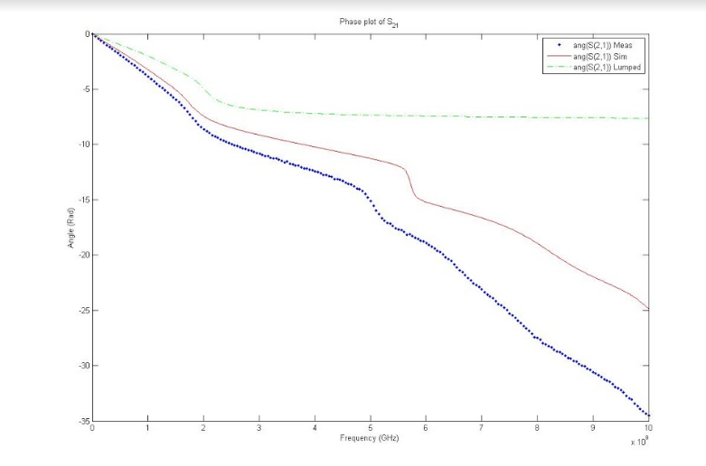

The angular phases are pretty much the exact same they start to spread further and further apart as you increase the frequency. We see that the lumped element filter is quite similar to 2GHz however it is drastically different after cutoff.

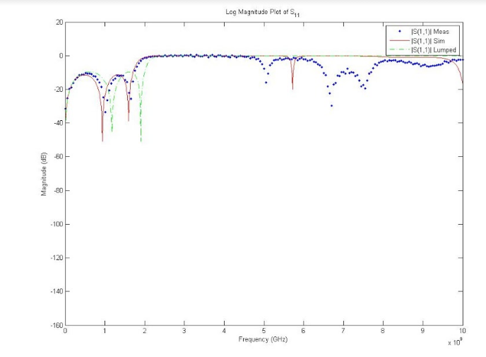

We note again that the measured and simulated values of reflection are practically the exact same up until 5GHz. Our lumped element is similar up until our cutoff from then it varies quite differently to our other measurements as it remains at 0dB.

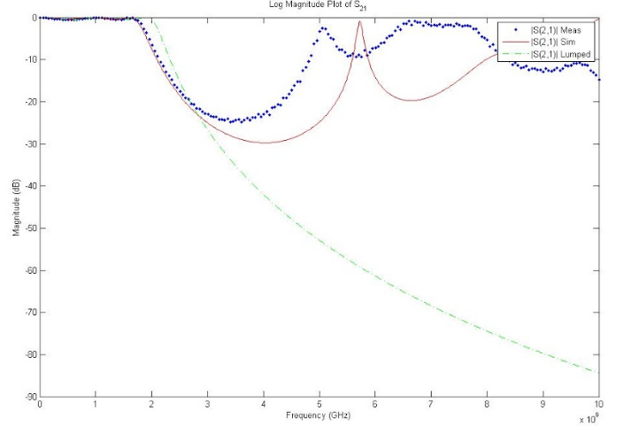

Finally our forward transmission coefficient for our measured and simulated microstrip filters are once again practically the exact same until our frequency becomes very large. Our lumped is also similar up until cutoff and from there it varies drastically.

We note from our graphs that our lumped element filter acts similarly to our ideal filter and our microstrip filters are more practical impementations.